Installation of the required library and nignx server htaccess config to run htpasswdgen.py

To Install dependency libaprutil1 for python-aprmd5 0.2.1 : sudo apt install libaprutil1-dev

- Download python-aprmd5 from : https://github.com/herzbube/python-aprmd5
- Extract the tar : tar xfvzo python-aprmd5-0.2.1.tar.gz
- cd python-aprmd5-0.2.1
  - ./setup.py build
- Install. If you have system administration rights, just do this
  - ./setup.py install
  - or if you are not and u are a sudoer : sudo ./setup.py install
- Test if it’s ready to be used:
  - ./setup.py test

For more reference: https://github.com/herzbube/python-aprmd5/blob/master/doc/INSTALL

In our case to be able to run our htpasswdgen.py , the above steps are enough to start running our htpasswd generator script.

Run in terminal: python htpasswdgen.py username password (which should looks like this:)

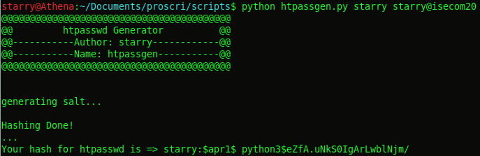
copy the result: starry:$apr1$ python3$eZfA.uNkS0IgArLwblNjm/ in to .htpasswd file and copy the file into the directory you wanna protect under nginx root folder or paste under /var/www/html/ to protect whole page.

htpasswdgen.py
#!/usr/bin/python
from aprmd5 import md5_encode
import argparse
from urllib2 import urlopen
import os
import sys
import random

print "@@@@@@@@@@@@@@@@@@@@@@@@@@@@@@@@@@@@@@@@@"
print "@@ htpasswd Generator @@"
print "@@-----------Author: starry------------@@"
print "@@-----------Name: htpassgen-----------@@"
print "@@@@@@@@@@@@@@@@@@@@@@@@@@@@@@@@@@@@@@@@@"
print "\n"

if len(sys.argv) < 2:
print "Usage : python htpassgen.py <username> <passwd>"
print "Example : python htpassgen.py starry starry57422Y"
sys.exit(0)

username = sys.argv[1]
passwd = sys.argv[2]

print "generating salt...\n"

url = 'https://slackbuilds.org/ChangeLog.txt'
with open('words.txt','w') as f:
f.write(urlopen(url).read())
salt = ""
salt += open('words.txt','r').read().split(",")[8]
salt += random.choice(salt)

def hashing_method(passwd_hash, salt):
hashed = md5_encode(passwd_hash, salt)

print 'Your hash for htpasswd is =>', username+':'+hashed

def main():
print 'Hashing Done!\n...'
passwd_hash = passwd
hashing_method(passwd_hash, salt)

if __name__ == '__main__':
main()

Ngnix config:

# nano /etc/nginx/conf.d/default.conf [For CentOS based systems]
OR
# nano /etc/nginx/nginx.conf [For CentOS based systems]

# nano /etc/nginx/sites-enabled/default [For Debian based systems]

Add these lines into it:

auth_basic "Login";
auth_basic_user_file /home/tecmint/.htpasswd;

My example of nignx.conf
nano /etc/nginx/sites-enabled/default
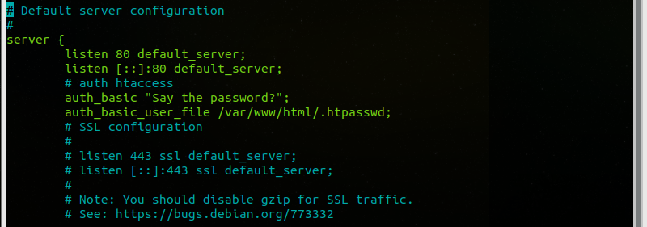

restart the ngnix server:

# systemctl restart nginx
OR
# service nginx restart

